Nepal Engineering College
(Affiliated to Pokhara University)



Report on:
LAB 5: Digital FIR filter

Submitted By: Submitted To:
Name: Aruna Thapa Department of Electrical
CRN: 021-311 and Electronics Engineering
Date: 1/29/2026

Objective
To implement and analyze low-pass FIR filters using different window functions in MATLAB. We compute the desired impulse response hd[n], apply windowing, and analyze frequency responses using built-in and user-defined methods.

Theory (Summary)
The ideal low-pass FIR filter has infinite impulse response:

hd[n] = { (ωc/π) , n = 0
sin(nωc)/(nπ) , n ≠ 0 }

This impulse is non-causal and must be truncated and shifted to design a practical FIR filter. Window functions such as Rectangular, Hamming, Hanning, etc., are used to control ripple and transition width.

Write a MATLAB program that computes the above approximation for a low pass filter with a cut-off frequency ωc = 0.5π rad/sample. Assume the order of this filter to be M = 21. (This is the desired impulse response of the system i.e. hd[n]. You can try this for different values of ωc and M)

% CRN: 021-311- Ideal Impulse Response
M = 21; % Filter length
wc = 0.5 * pi; % Cutoff frequency
tau = (M - 1) / 2; % Center index
n = 0:M-1; % Sample indices
hd = zeros(1, M); % Initialize impulse response

for i = 1:M
if (n(i) - tau) == 0
hd(i) = wc / pi;
else
hd(i) = sin(wc * (n(i) - tau)) / (pi * (n(i) - tau));
end
end

% Plot after loop
stem(n, hd, 'filled');
title('CRN: 021-311 - Ideal Impulse Response h_d[n]');
xlabel('n');
ylabel('h_d[n]');
grid on;

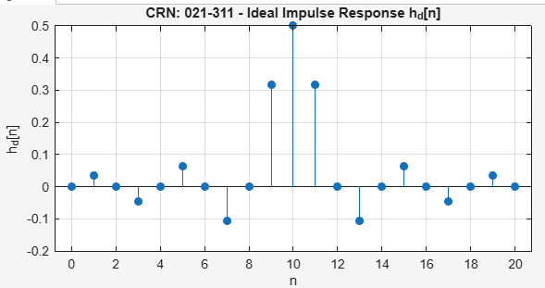

This figure demonstrates ideal low-pass filter impulse response showing the sinc function behavior with maximum amplitude at the center (n=10) and decaying oscillations on both sides.

Write a MATLAB program to calculate different window functions, w[n] above and plot frequency responses. Compare with the built-in MATLAB functions. [hint: use freqz() function for frequency response or use windows visualization tool wvtool(w)]
% CRN: 021-311- Frequency Response of Window Functions M = 21;
w_rect = rectwin(M)'; w_bart = bartlett(M)'; w_hann = hann(M)'; w_hamm = hamming(M)'; w_black = blackman(M)';

figure;
freqz(w_rect, 1, 512);
title('CRN: 021-311- Rectangular Window');

figure;
freqz(w_bart, 1, 512);
title('CRN: 021-311- Bartlett Window');

figure;
freqz(w_hann, 1, 512);
title('CRN: 021-311- Hanning Window');

figure;
freqz(w_hamm, 1, 512);
title('CRN: 021-311- Hamming Window');

figure;
freqz(w_black, 1, 512);
title('CRN: 021-311- Blackman Window');

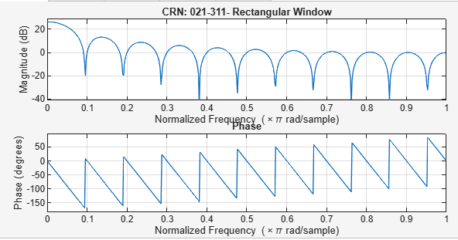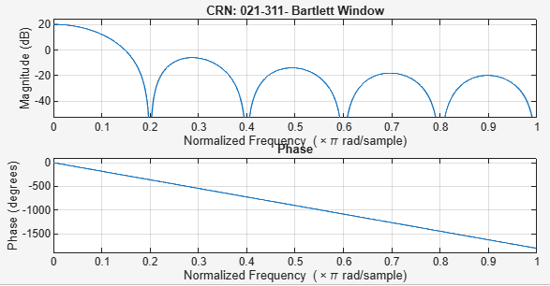

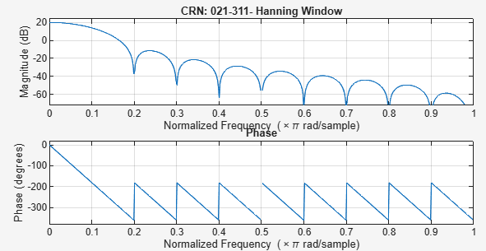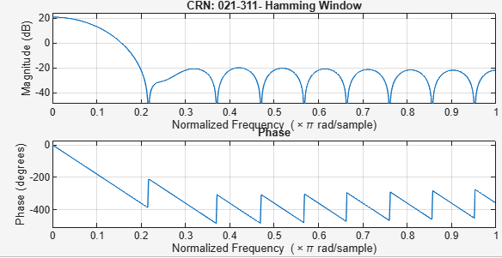

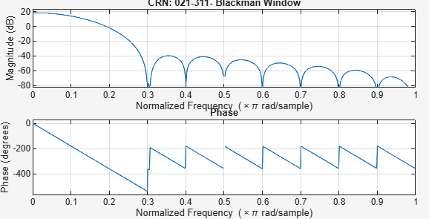

This figure demonstrates frequency response of different window functions using wvtool() in MATLAB, demonstrating the trade-off between main lobe width and side lobe suppression for each window type.

The impulse response h[n] is given by h[n] = hd[n]. w[n]. Write a MATLAB program to compute impulse response h[n] for different window functions and plot frequency responses.

% CRN: 021-311- FIR Filter Responses for Different Windows

% Step 1: Filter specifications
M = 21;
wc = 0.5 * pi;
tau = (M - 1) / 2;
n = 0:M-1;
hd = zeros(1, M);

% Step 2: Compute ideal impulse response hd[n]
for i = 1:M
if (n(i) - tau) == 0
hd(i) = wc / pi;
else
hd(i) = sin(wc * (n(i) - tau)) / (pi * (n(i) - tau));
end
end

% Step 3: Define window functions
w1 = rectwin(M)';
w2 = bartlett(M)';
w3 = hann(M)';
w4 = hamming(M)';
w5 = blackman(M)';

% Step 4: Multiply hd[n] with window functions
h1 = hd .* w1;
h2 = hd .* w2;
h3 = hd .* w3;
h4 = hd .* w4;
h5 = hd .* w5;

% Step 5: Compute frequency responses
[H1, w] = freqz(h1, 1, 512);
H2 = freqz(h2, 1, 512);
H3 = freqz(h3, 1, 512);
H4 = freqz(h4, 1, 512);
H5 = freqz(h5, 1, 512);

% Step 6: Plot magnitude responses
figure;
plot(w/pi, 20*log10(abs(H1)), 'r'); hold on;
plot(w/pi, 20*log10(abs(H2)), 'g');
plot(w/pi, 20*log10(abs(H3)), 'b');
plot(w/pi, 20*log10(abs(H4)), 'm');
plot(w/pi, 20*log10(abs(H5)), 'k'); hold off;

title('CRN: 021-311 - FIR Filter Frequency Responses');
xlabel('Normalized Frequency (w/\pi)');
ylabel('Magnitude (dB)');
legend('Rectangular', 'Bartlett', 'Hanning', 'Hamming', 'Blackman');
grid on;

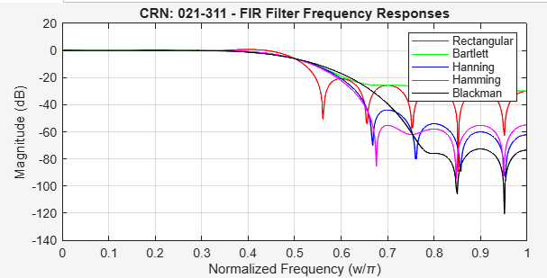

This figure demonstrates frequency response (in dB) of FIR filters designed with different window functions, clearly showing how the Blackman window provides the best stopband attenuation while the rectangular window has the sharpest transition but highest ripple.

Use fir1() MATLAB command to implement FIR filter using window method and also try Kaiser() command as window function.
% CRN: 021-311- FIR Filter Using fir1() and Kaiser Window

M = 21;
beta = 5;
w_kaiser = kaiser(M, beta)';
h_fir1 = fir1(M - 1, 0.5, w_kaiser);

freqz(h_fir1, 1, 512);
title('CRN: 021-311- FIR Filter using fir1() and Kaiser Window');

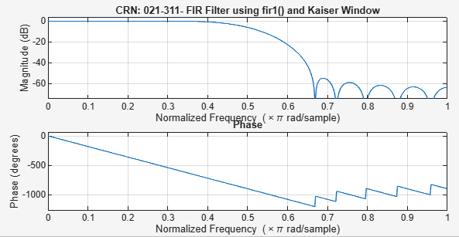

This figure demonstrates frequency response of FIR filter using fir1() with Kaiser window, demonstrating the adjustable parameter β=5 that provides a good balance between transition width and stopband attenuation.

- Try to Implement HPF, BPF and BSF as given in table below:
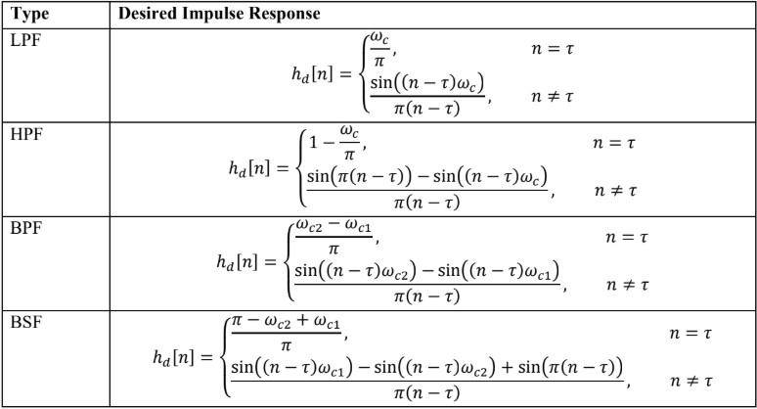

clc;clear;close all;

%% Filter parameters
N = 51; % Filter length (odd preferred) tau = (N-1)/2; % Delay
n = 0:N-1; % Index

wc = 0.4*pi; % Cutoff frequency for HPF wc1 = 0.3*pi; % Lower cutoff for BPF & BSF wc2 = 0.6*pi; % Upper cutoff for BPF & BSF
% High Pass Filter (HPF) h_hpf = zeros(1,N);

for i = 1:N
if n(i) == tau
h_hpf(i) = 1 - wc/pi; else
h_hpf(i) = ( sin(pi*(n(i)-tau)) - sin(wc*(n(i)-tau)) ) ...
/(pi*(n(i)-tau));
end end

% Band Pass Filter (BPF) h_bpf = zeros(1,N);

for i = 1:N
if n(i) == tau
h_bpf(i) = (wc2 - wc1)/pi; else
h_bpf(i) = ( sin(wc2*(n(i)-tau)) - sin(wc1*(n(i)-tau)) ) ...
/(pi*(n(i)-tau));
end end
% Band Stop Filter (BSF) h_bsf = zeros(1,N);

for i = 1:N
if n(i) == tau
h_bsf(i) = (pi - wc2 + wc1)/pi; else
h_bsf(i) = ( sin(wc1*(n(i)-tau)) - sin(wc2*(n(i)-tau)) ...
+ sin(pi*(n(i)-tau)) ) /(pi*(n(i)-tau));
end end

% Plot Impulse Responses figure;
subplot(3,1,1);
stem(n, h_hpf, 'filled'); title('Impulse Response of HPF'); xlabel('n'); ylabel('h[n]');

subplot(3,1,2);
stem(n, h_bpf, 'filled'); title('Impulse Response of BPF'); xlabel('n'); ylabel('h[n]');

subplot(3,1,3);
stem(n, h_bsf, 'filled'); title('Impulse Response of BSF'); xlabel('n'); ylabel('h[n]');

% Frequency Responses figure;

freqz(h_hpf,1,1024); title('Frequency Response of HPF');

figure; freqz(h_bpf,1,1024);
title('Frequency Response of BPF');

figure; freqz(h_bsf,1,1024);
title('Frequency Response of BSF');
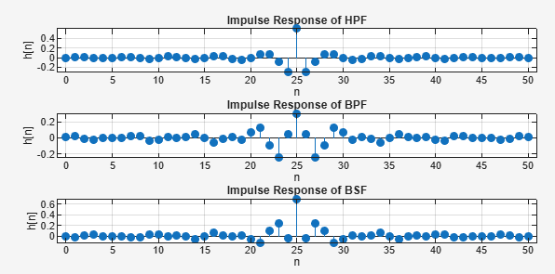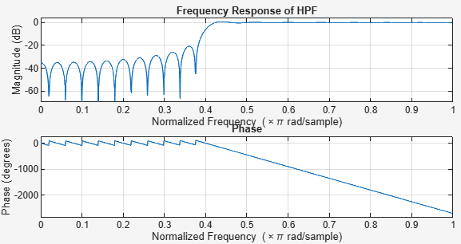

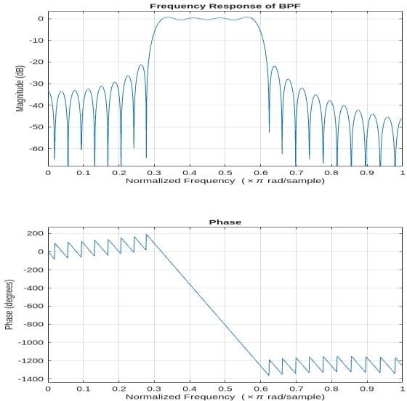
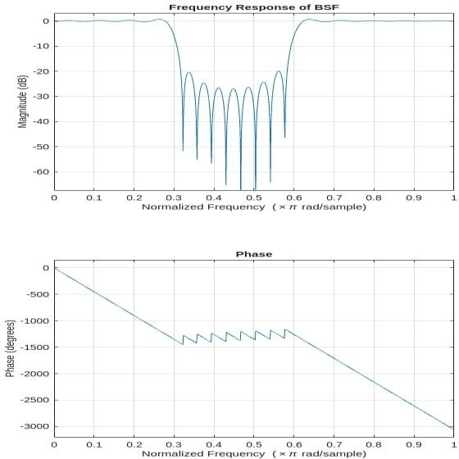

The figures show the impulse, frequency, and phase responses of FIR digital filters. The impulse responses indicate linear-phase behavior, while the frequency responses demonstrate the operation of high-pass, band-pass, and band-stop filters. The linear phase plots confirm minimal phase distortion in the filtered signals.

Conclusion
In this lab, we successfully:
- Computed the ideal low-pass filter impulse response.
- Applied various window functions to truncate and shape the response.
- Plotted and compared their magnitude responses.
- Implemented FIR filter using MATLAB built-in tools like fir1() and kaiser().
These steps help understand practical FIR filter design using windowing technique in digital signal processing.

